Walter Woodward
1897-1918

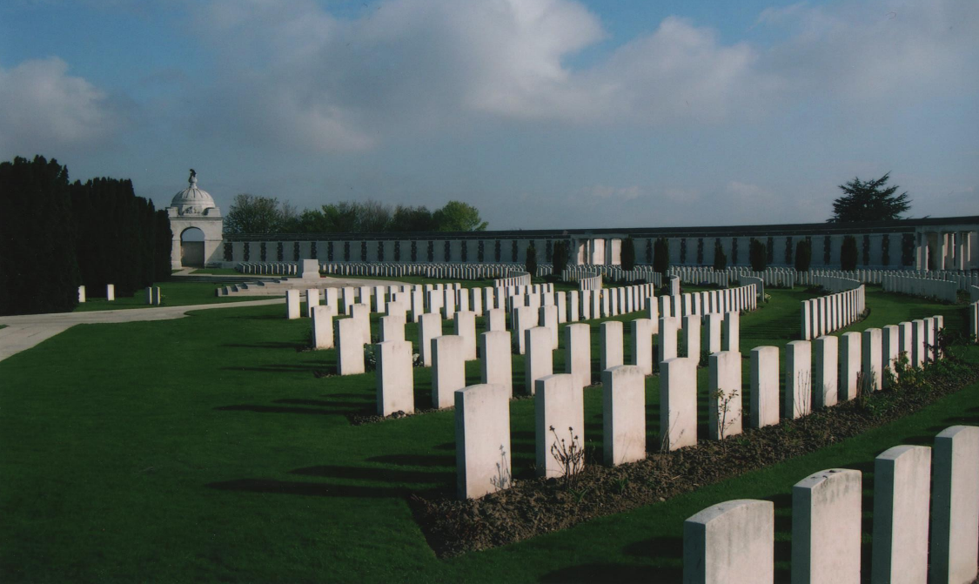

Walter was born on May 1st 1897 at 1 St. Domingo Road in Liverpool. He was the second youngest of the Woodward family; the youngest being Wilfred.

Walter was only thirteen when his mother Ellen passed away from cancer.

There are very few surviving records relating to Walter that would provide an insight into his short life and sadly there are no known surviving photographs.

It is very likely that upon leaving school he would have found employment within the family bakery. Following the death of his mother in 1911, the family moved to their new home in Deyes Lane, Maghull.

Based on surviving records, when Walter was killed in 1918 his father James was given a war gratuity of £9. This would indicate that Walter enlisted for service around April/May 1916.
and was was posted to no. 4 Company of the 20th King’s Liverpool (Pals) Battalion.

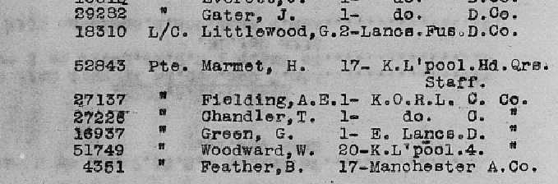
With basic training lasting three months, it would have likely been in the July or August of 1916 that Walter joined the Company on the Western Front that were reinforcing the Battalion following its action at the Somme.

Through surviving records we know that Walter was admitted to the 31st Ambulance Train on October 26th 1916 before being discharged and returned to his Company the following day.

The 20th King’s was then involved in a number of engagements alongside the other Pals Battalions the 17th, 18th and 19th before it was disbanded on February 8th, 1918 and its numbers used to reinforce the other Pals Battalions. Walter was transferred to the 18th King’s Liverpool.

On the night of April 27th 1918, the Battalion moved into the line near Voormezeele in the Scherpenberg area (South of Ypres) and spent the duration of the 28th making improvements to the defences.

Just after 03:00am on the morning of the 29th, a ferocious German barrage opened up on their positions with a terrific bombardment of high explosives, shrapnel and gas shells. It was the final day of the Battle of Lys and German forces were launching a major offensive against British positions in the area.

The first German assault on a position being held by men of the 18th Battalion occurred at 6:00am and was directed at a listening post near Ridge Wood, occupied by men of No.4 Company. The German’s successfully took the position before it was subsequently retaken by British forces a short time afterwards when Company Sergeant Major G. Sutton of No.1 Company single handedly retook the position using Mill Bombs to clear out the twenty or so German’s occupying the position.

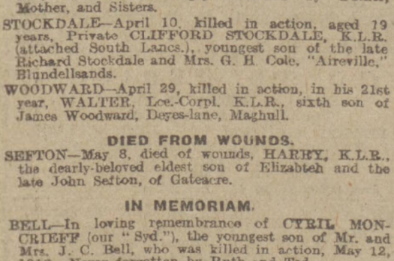
The 18th were successful in repelling any further attempts by German forces to take their positions but the casualties were high. The situation became so intense at one point that the battalion War Diary records that at one point British artillery was coming down on top of the British positions, as they attempted to bring an end to the German assault.
Liverpool Echo on the May 13th 1918

Ultimately the German offensive failed and the Battle of Lys was over.

The exact circumstances around Walter’s death that day are unknown. He was just two days short of his 21st birthday.

He was one of twenty three men from his battalion who were killed that day, with more to die from wounds in the days that followed.

Each of them are listed on the Tyne Cott Memorial to the missing in Ypres and have no known grave. However, on November 13th 1975 an article appeared in the Liverpool Echo entitled “A Soldiers Will”.

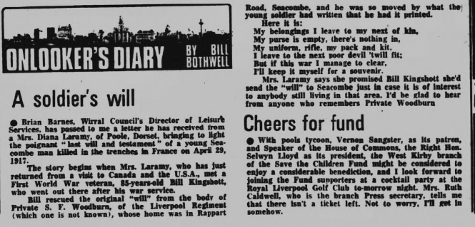

The articles would suggest that following the battle, the men of the 18th Battalion who lost their lives that day did indeed receive a proper burial.

With this in mind and on a personal note, the hope is that one day they are identified and that Walter can then finally be laid to rest in the presence of his family.

