Lance Corporal James Harold Woodward
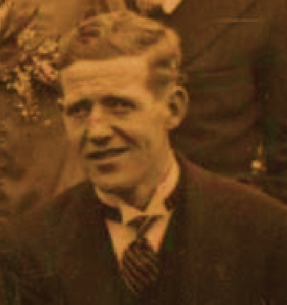
1894-1972
Born March 27th 1894, Harold like the rest of the family grew up at Navarino Cottage on St. Domingo Road Liverpool In 1909 at the age of 15, he won a Merseyside Competition to find the boy with the best handwriting and this led to him beginning his career as an office boy at the Birkenhead Register Office.
Following the death of his mother, he moved with the rest of the family to Deyes Lane in Maghull.
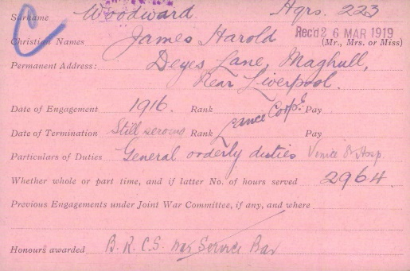
As a result of an accident in his youth, Harold was partially paralysed on one side and consequently when war was declared in 1914 he would not have been suitable for active service on the frontline. Instead he enlisted in 1916 and served as a Red Cross Volunteer at the Venice Street Hospital carrying out General orderly duties where for a brief period he was joined by his brother Stan (J. S. P. Woodward).
British Army, British Red Cross Society Volunteers 1914-1918 index card

Harold remained at the Hospital for the duration of the war with the rank of Lance Corporal at the end of hostilities was awarded the British Red Cross Society War Service Bar for his services.
Harry went on to marry Mary Jamieson in 1924 and together they had one daughter Anita who was born in 1926.
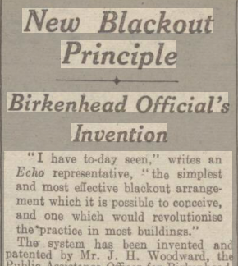
In the years following the war he moved to 120 Herondale Road in Liverpool with his family and became Public Assistant Officer & Superintendent Registrar for Birkenhead.
Liverpool Echo - Tuesday 22 September 1942
At the outbreak of the Second World War, he was also responsible for the requisitioning of buildings for use as shelters to accommodate people blitzed from their homes.
In the winter of 1941, following a number of complaints received about inefficient blackouts at places under his control, he started experimenting with a new system to improve the effectiveness of the blackout measures.
He also served as Superintendent of the Birkenhead Corps of the St. John Ambulance during the conflict.
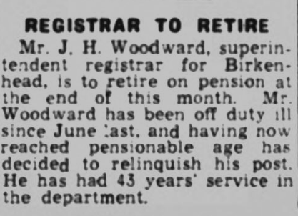
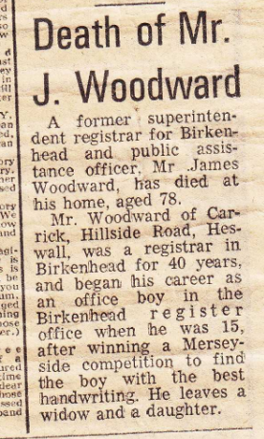
Harold later moved to Carrick, Hillside Road in Heswall and retired at the end of March 1957.
Harold remained in Heswall with his wife Mary until he passed away on August 29th 1972. His daughter Anita went on to live in Canada with her husband.
Harold is buried at the St. Peter’s Church in Heswall alongside his wife Mary who passed away on April 9th 1979 and only a few feet away from the family grave where his brother Richard had been laid to rest in 1918.

