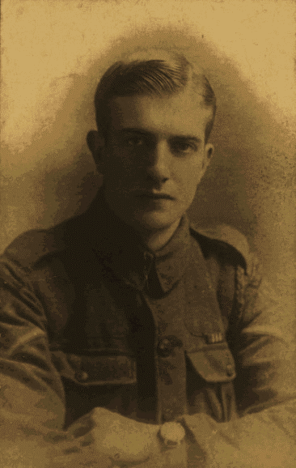
Joseph Stanley Pemberton Woodward M.M of “C” Company the 1/6th King’s Liverpool Rifles

Lance Corporal Joseph Woodward (1895-1979), or Stan for short, was born on October 8th 1895 in St. Domingo Road, Liverpool.
He was one of six brothers who served in the Great War and before the war worked as a manager at the Family Bakery. Stan enlisted on the December 8th, 1915.
Stan lived in Deyes, Maghull with his father James, his sister Nellie and five of his brothers. They had moved there a few years earlier, following the death in 1911 of Stanley’s mother Ellen.
Surviving records from the British Army - British Red Cross Society Volunteers archives show that for a period of 1916, he was performing general duties at the Venice Street Hospital in Liverpool. Here he would have worked there alongside his brother Harold who was also serving as an orderly at the Hospital.
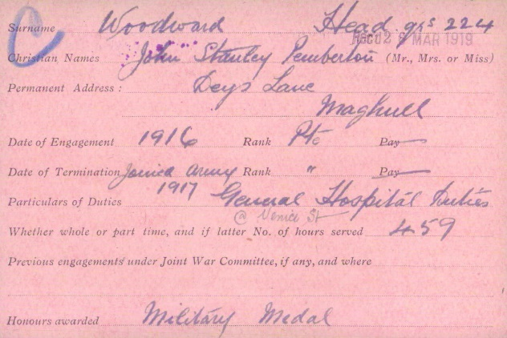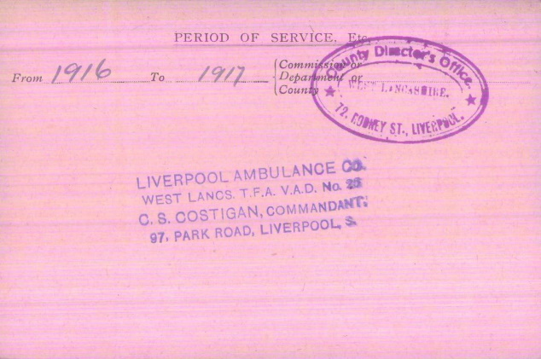
The skills that Stan would have picked up during this period, would no doubt would have served him well as a Stretcher Bearer on the Western Front.
His Service Record and Paybook suggest that he was probably at the hospital from September 14th 1916 until January 1917.
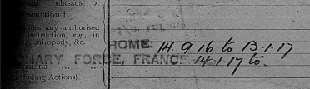
On January 14th, 1917 he departed from Folkestone in Dover and arrived in Boulogne later that day. The following day he travelled on to Etaples, where he joined the 24th Infantry Base Depot before officially joining the 1/6th King’s Liverpool Battalion on January 18th.
Upon joining the Battalion, he was assigned to ‘C’ Company and began serving as one of the Battalion’s Stretcher Bearers.
During this period the Battalion spent the majority of their time moving in and out of the line in the area around Ypres, Belgium.
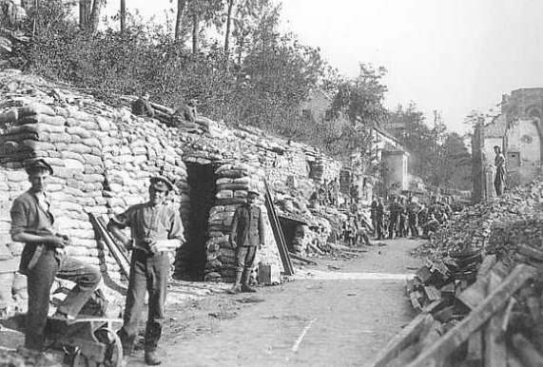
Menin Road, near Railway Wood
On a number of occasions the Battalion diary references being in the line near Railway Wood and in a letter to the Liverpool Echo dated the February 22nd 1963 titled the Silent Army, Stan recounted one of his earlier wartime experiences involving the brutal underground war that was being fought in that area during 1917 This is what he wrote:
“May I add my humble tribute to the many who remember the deeds of that early “underground” army of the First World War, brought to light by the recent instalment of the “Moles” story.
Early in 1917 I was hurried from a dugout on the Menin Road to surely one of the worst British sectors on the West Front – Railway Wood, Ypres, with the old 1/6th Liverpool Rifles. It was a sector almost hollow with mines and even No Man’s Land was blown up at regular intervals despite being only 50 yards wide.
Our Platoon was summoned at the trot to a mine shaft in Mud Lane, where a German “camouflet”, or counter mine had trapped several miners. At the deepest of the mine – disaster point – naked moles were digging at tremendous speed, and we were placed up the tunnel steps every few yards in a human chain to get rid of the tons of earth in the filled sandbags.
I was the last man and stood on the top of the parapet with strict orders to empty the bags, and not to dump the contents as the Germans could more easily spot the bags than the loose earth.
I moved by stages down the shaft to help carry the newly dug earth. When I reached the digging miners who were trying to release the trapped victims, I was a lather of sweat, after having almost frozen. When I got back by stages to my top of the trench job an order reached me to go down the shaft.
The fatigue was over. Several of the Welsh miners who had been rescued joined us in a thankful cup of tea, but many bodies had not been recovered. I said to one of these heroes “I wouldn’t like your job!”
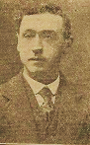
He replied; “When we hear those Minnies crashing, we feel we wouldn’t want like your job upstairs, but we often think of you!”
Ever since that experience, I have thought more of that silent army.”
On July 29th 1917, the battalion moved into the line at Congreve Walk in preparation for the Third Battle of Ypres (Battle of Passchendaele). At 8PM, 150 men from both ‘B’ and ‘C’ were supplied for working parties. There was heavy shelling in the area and the battalion suffered fifteen casualties, one of whom was Stanley’s friend Rifleman Rufus Dunn.
Rufus had been slightly older than Stanley and was also serving in ‘C’ company. Like Stan, Rufus had also lost one of his parents when he was still young.
Rifleman Rufus Dunn
From Blackburn, he had worked as a decorator before the war and lived with his wife Annie and her children from a previous relationship.
During one of his visits back to Belgium after the war, Stan visited the Potijze Chateau Grounds Cemetery where Rufus is buried and took the below photograph.
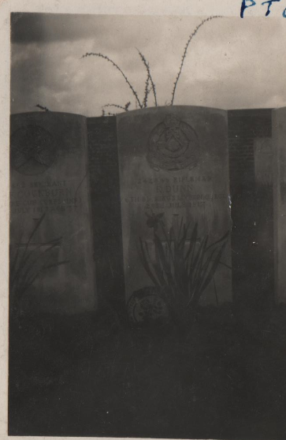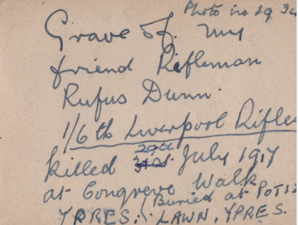
When the Third Battle of Ypres commenced on the July 31st 1917, the ground was thick mud and the terrain potted with craters – the trenches themselves flooded. In the early hours of the 31st the battalion launched an offensive action against German positions and suffering sixty-two fatalities and 154 wounded as a result.
During the engagement, Stan received a contusion to his right hand on some barbed wire. As a result, he is listed amongst those wounded. He would return to the battalion 8 days later.
Entry into Casualty Admittance Book
On September 20th 1917 during the battle of Menin Road, the battalion was tasked with capturing German positions at Hill 35 & Hill 37. The battle would see the battalion suffered extremely heavy casualties in achieving their objectives with eighty-one dead and 161 wounded.
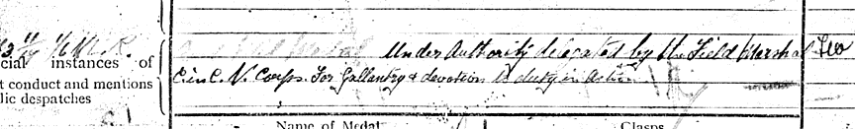
It was during this engagement that Stan’s actions a Stretcher Bearer earned him the Military Medal but sadly over the years the citation has been lost, as has the story of how it was earned.

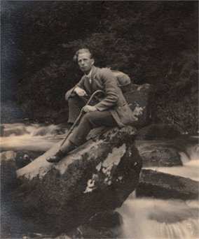
He was wounded again on November 30th 1917, near Pigeon Quarry (Epehy, France) during a German offensive against British positions in that area.
Private Carl Johan Jacobson
His future brother-in-law Carl Jacobson (also a stretcher bearer), was serving with the 1/10th King’s Liverpool Scottish at Pigeon Quarry at the time. He was wounded and captured during the battle when the Quarry was overran. He was later moved to Switzerland as a Prisoner of War.
During the Battle of Lys, Stanley was placed in charge of the H.Q. Battalion Runners’ section on April 9th, 1918. He was also made senior ‘Colonels’ guide for Lt. Colonel John McKaig and one of his responsibilities was to escort McKaig around the trenches.
In a letter to the Liverpool Echo dated December 11th 1961, entitled Pied Piper of Vaudracourt, Stanley wrote the following:
“In the early part of 1918 when I was in the infantry near Bethune, I was in charge of H.Q. Battalion Runners’ section, which carried dispatches to the forward companies, and my special job was to accompany the Battalion Commander around the line.
Our small Section, when out on rest in Vaudracourt, had adopted one of many of the stray dogs usually left by fleeing civilians, but this one turned out to have been trained without a doubt to carry messages. We learned this one day when we mislaid a dispatch, only to find he had calmly taken charge of it and refused to give it up until he had delivered it safely to its destination.
Our pet became a great favourite with the Colonel, and there was much sadness when it was discovered he had disappeared from the camp. Day followed day without sign of our pal, and I walked miles in an effort to trace him. Imagine how pleased I was when I spotted him in a Gunners’ camp on the Bruayn road, but although he was wild with delight, the sergeant in charge refused to give him up.
The following day, I borrow our dog’s lady friend from the orderly room staff and took her on her lead for an innocent stroll through the Gunners’ camp. But there was no sign of my quarry, although the walk was attracting many other canine admirers.
On reaching our camp I must have resembled the Pied Piper, followed by dogs – and more dogs. I then saw the Colonel [John McKaig] fondling my objective. He roared laughing when I told him how I had snared our pet (1). The dog endured with us the famous battle for Givenchy on April 9th, 1918 and completed the war, despite gas and all other inconveniences.
Owing the quarantine difficulties, we could not get Rastus to Blighty and a Belgian family adopted him and let us know his progress until his death.
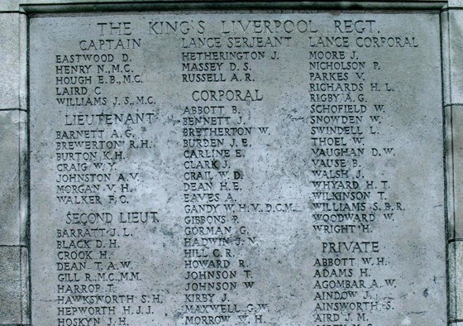
I was sent to hospital on Armistice’s Day. The Colonel’s last words to me were: “The way you got that dog back to Vaudracourt should lead you join the Police Force” which I did!”
On April 29th 1918, Stanley’s second youngest brother Lance Corporal Walter Woodward (51749) who had been serving with the 18th King’s Liverpool (Pals) Battalion was killed in action. He was only 21 when he was killed. He is listed on the Tyne Cott Memorial to the missing and like so many, has no known grave.
This was followed a few months later by the death of his older brother Harry (28305), who was killed on August 10th 1918 whilst serving with the 1/4th King’s Shropshire Light Infantry during the relief of the 8th North Staffordshire’s near La Bouverie.
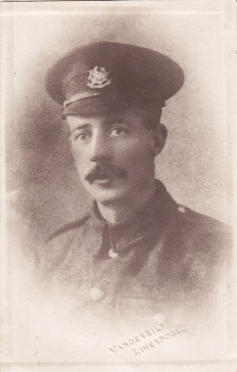
Harry left behind his wife Flo and two young children. He is buried at the Sandpits Cemetery, Fouquereuil.
A month later during the Hundred Day Offensive, Stanley’s second eldest brother Company Sergeant Major Richard Woodward (241159) was seriously wounded on September 27th 1918.
He had been serving with the 2/6th King’s Liverpool Battalion. He had been struck in the head by a bullet, causing serious damage. His company had been preparing for an offensive action near the Canal Du Nord at the time.
Private Harry Woodward in 1917
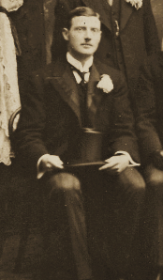
Sadly Richard died of his injuries on October the 27th 1918 at the 1st General Hospital Camberwell in London. He was awarded the Meritorious Service Medal and was buried alongside his mother in the family grave in Heswall.
It is likely that the above photo is of R. J. Woodward.
On November 8th 1918, Stanley was admitted to the Maghull Military Hospital suffering from neurasthenia and would remain there until February 13th, 1919.
The hospital itself was conveniently located only a short distance from the family home in Deyes Lane.
After the war, Stanley would go on to join Liverpool City Police alongside his brother Wilfred.
In 1927 he joined ‘G’ Division in Old Swan and was later promoted to the rank of Police Sergeant.
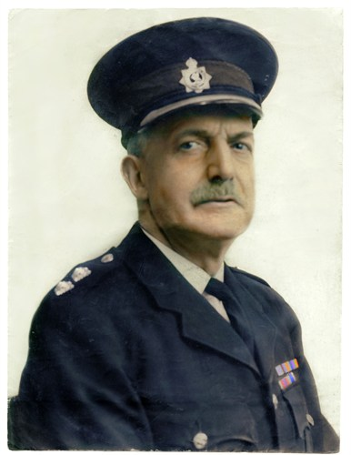
He spent some time at Aigburth Police Station and he was involved in dealing with the escape of Mickey the Chimp from Aigburth Zoo in 1938.
Twenty years later he was promoted to the rank of Inspector at ‘A’ Division and he finally returned to the Old Swan in 1951 before retiring on March 15th1954 after 34^{1/2} years’ service.
During his time at Liverpool City Police he was well known for his charity work, organising hundreds of concerts and old-time dances. He received numerous commendations and awards, including the Coronation Medal in 1953 and also medals for Good Conduct and Long Service.
Inspector J. S. P. Woodward (1953)
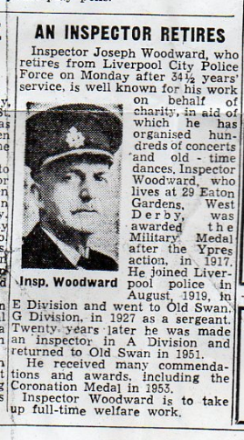
He remained extremely active following his retirement, working full time as a Police Court and Prison Gate Missioner and played an active role within the community.
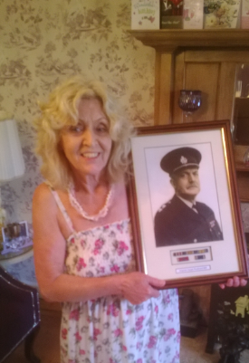
Throughout his life, he continued to attend the annual Liverpool Rifle Association reunion dinners.
Ann with a photograph of her father in 2014
In his final years aged 74 he moved with his wife to Bryn Heulog, Llanbedr Hall in Ruthin. On September 5th 1979, he passed away. He was laid to rest at St. Peters Church in Ruthin leaving behind his wife Ruth Woodward and his only surviving child Ann. Sadly his first child Eric John Woodward had tragically passed away in 1935 aged 4 years old after an accident at their home in Eaton Gardens.
Liverpool Echo - Friday March 12th 1954
It is notable that Stanley’s experiences during the war continued to affect him for the rest of life. In later years, his wife Ruth forbade him from reading the book Undertones of War´ by Edmund Blunden as it would cause Stanley to wake up in the middle of the night screaming “like an animal”.
Poem: Ypres 1917
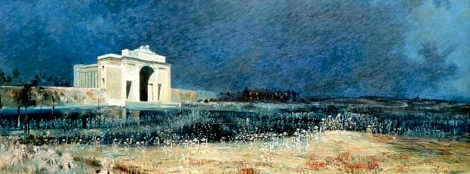
Not till Seventeen had I yet seen
That battlefield of smothered green.
Where almost nature’s all had sped,
Crushed down by British dead.

When I first entered into that town
T’was even’, and the sun gone down.
But in the faint artillery light,
I first beheld the battle night.

I dreamt of glory, but why wait?
Yes, why sneak through the Menin Gate?
As cautious as an airship fly,
They’d been before, and thus knew why!

For in that pause, the secret pent,
Burst on the ghastly firmament.
The shells fell thick with cruel tear.
Had Jerry guessed relief was there?

And fast away the transport clattered,
And I was whole, but mud bespattered.
Yet I still think of those few shells,
Aye, coupled with those wounded yells.

And on we went past sentry post,
And shattered house where shadows float.
Into the square of that great town,
Cloth Hall stood, but now was down.

Oh! Wondrous building wrecked by shell
Had sunk to dire disaster swell.
The very spots that sheltered brave,
Turned into everlasting grave.

Graves of men of British Race
Who’d foughten on. Had not the place
Closed down on them, just like a pall.
A thousand deaths -scant funeral!

For in reserve were these days spent,
And then we to the ditches went.
But in these days I studied well
The war as dug-out sentinel.

At dead of night, with bayonet bright
I stood beside the dug-out site.
Heard screaming shell and limber pass,
And spread alarm for cruel gas.

Oh, think men with rubber mask,
Blind and struggling for a gasp
Of gods free air, just for a spell.
But let’s back to the sentinel.

Still on the Menin Road they stand,
Facing east, their promised land.
Reward!! Their glory they await.
ETERNAL LIGHT FLOODS THE MENIN GATE.
Unpublished: By J. S. P. Woodward

