WW1 MAGHULL ARTEFACTS BOX PAGE 2

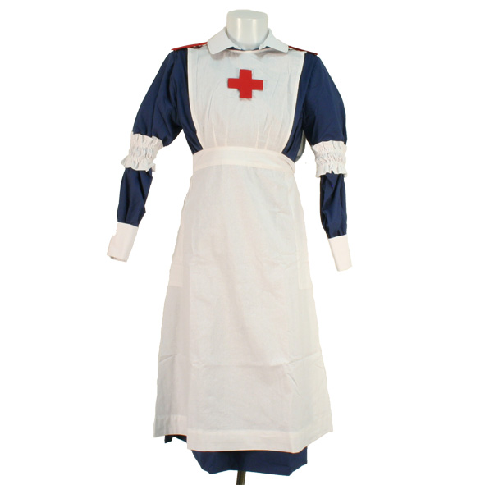 | WW1 Children's VAD (Voluntary Aid detachment) blue cotton ward dress.  - Full length Blue cotton dress  - removable cotton collar  - Removable Shoulder board  - white apron  - White cuffs  - white elasticated arm bands  - Head scarf
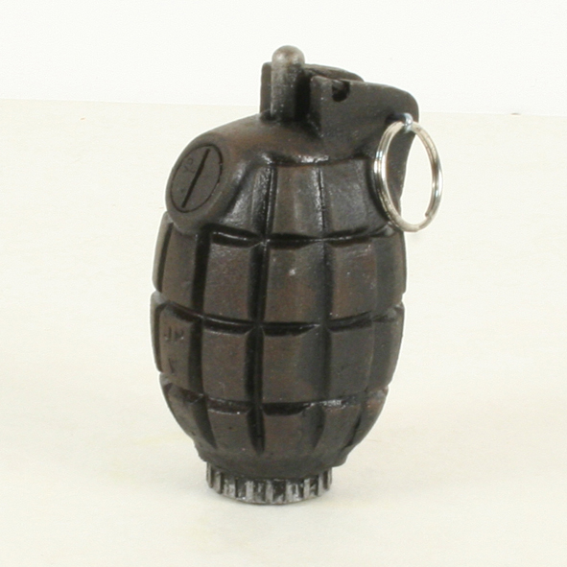 | No34 Grenade  The No.34 Hand Grenade was developed to counter the introduction of the German Model 1917 Eierhandgrante. The British explored a number of ideas for this small fragmentation grenade to give the maximum throwing range,  The No.34 Mk.III has a percussion actuated delay fuze. The pin is removed and the plunger is slapped against a suitably hard object. The plunger cuts a shear wire and fires a primer cap, which ignites the delay which burns down to a detonator. There would have been a vent hole in the fuze body for escaping gases.  The No34 grenade was introduced at the end of 1917.  This is a replica Mills grenade which is solid resin with no moving parts.
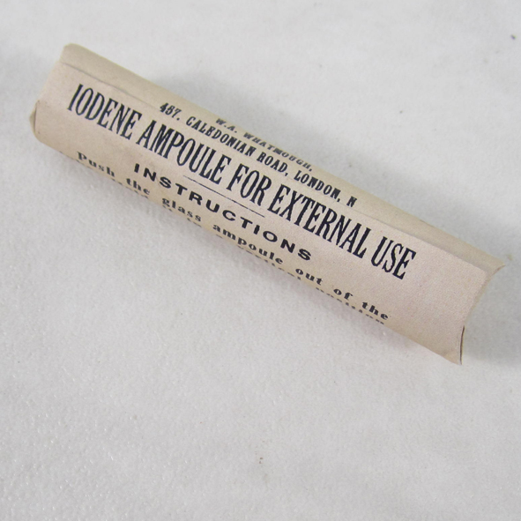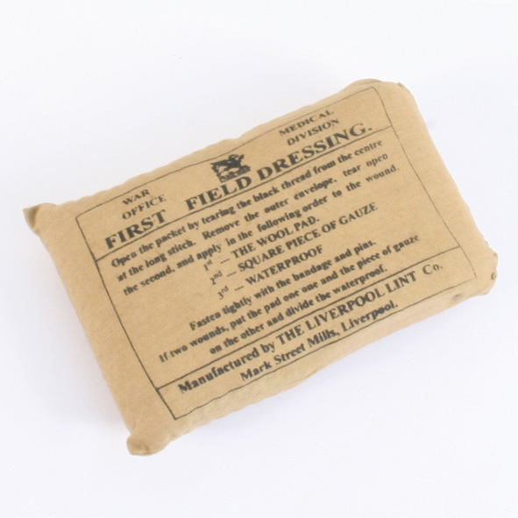 | Iodene Ampule and Field Dressing  During the great war 1914-1918 the British army soldier was issued very basic first aid kit which usually consisted of just one first field dressing which he kept in his tunic pocket.  If he was lucky he might have been able to acquire an Iodine ampoule which he would break on a hard surface and then pour the contents over his first Field dressing to help clean the wound and prevent infection.  These replica has packaging copied from an original with instructions on how to use. Please do not open.
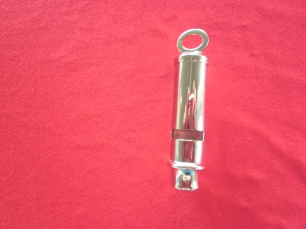 | Trench whistle and Lanyard  Used by officers in order to coordinate attacks
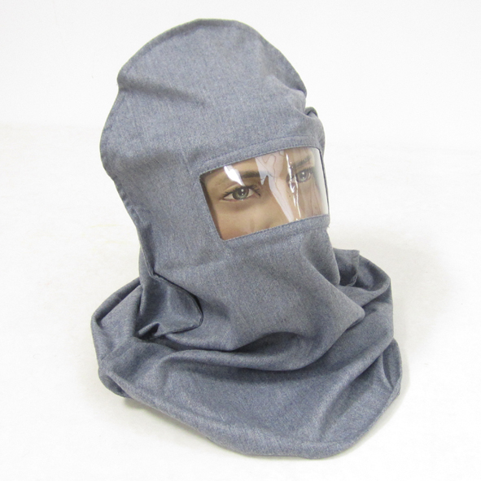 | Smoke Hood / Hypo Helmet  This is a reproduction of the British First World War grey wool Smoke hood/Hypo helmet which was first issued in May 1915.  This was issued to replace the Black Veil Respirator. The original smoke hood was made of grey flannel fabric with a celluloid one piece window. The grey flannel helmet was dipped in sodium hyposulphite (which is where it gets it Hypo helmet name from) which would prevent certain gases getting through the hood.  Although the design was an improvement over the Black Veil Respirator it was still not the best designed anti gas hood as it was too stuffy to wear for long periods of time. The Smoke hood was first issued on May 8th 1915. It was eventually replaced by the improved HP Hood which in turn was superseded by the far superior SBR gas mask.  This reproduction is made from the correct grey flannel material and celluloid one piece window but has not been dipped into any chemicals so is safe to handle and use, making it perfect for re-enactment, museum displays and hands on educational use.
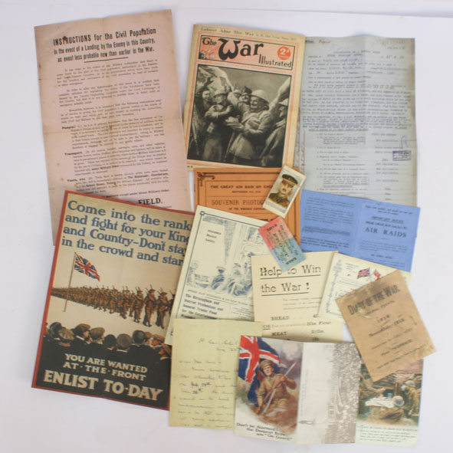 | WW1 Paperwork Pack  The set consists of reprints of original first war paperwork.  Contents includes:  - Home Front information inc what to do in event of an invasion.  - Medical report 1917  - Enlist to-day poster  - The war illustrated  - Collectors cards  - Air raids Notice  - Booklet on the Zepplin  - and more

